ADAPTIVE ALGORITHMS FOR QUANTIZATION ERROR NORMALIZATION OF DIGITAL ENCODER-BASED TACHOMETERS

Kukharchuk V.¹, Holodiuk V.¹, Koval A.¹, Vasilevskyi O.², Trishch R.^{3,4}
¹Vinnytsia National Technical University, Vinnytsia, Ukraine
²The University of Texas at Austin, Austin TX 78712, USA
³National Aerospace University “Kharkiv Aviation Institute”, Kharkiv, Ukraine.
⁴Mykolas Romeris Universiti, Vilnius, Lithuania

Abstract. The authors' analysis of the instantaneous and average values digital tachometer quantization error assessment in the dynamic measurements of angular velocity with an encoder allowed for the first time to obtain a mathematical model for calculating the critical speed numerical value for an exponential mathematical model that adequately describes the transient process of the electric machine’s operation. It was found that the value of the critical speed depends on the resolution ƶ of the encoder, the quantization frequency, the duration of the sample time interval, which variation allows to measure the angular velocity with a predetermined normalized value of the quantization error during the transient process of the electric machine from the lower to the upper measurement limit.
Keywords: Electric Machine, Transient Characteristic, Encoder, Transfer Function, Quantization Error Equation, Critical Speed, Adaptive Algorithm, Microcontroller Tachometer, Normalized Value of Quantization Error.

Introduction. Currently, to intensify the testing of electric machines (EM), most of the research is focused on the acceleration of the tests carried out in the "no load" experiment. The main one here is the transient characteristic (variable angular velocity over time n(t)), which is obtained in the dynamic mode of measuring object operation (electric machine) with practically zero moment of resistance on its shaft (MC≅0) [1-5]. A feature of the experimental studies of this characteristic is the determination with high accuracy in real time of the available dips, sudden emissions, synchronous dips, which significantly affect the vibroacoustic characteristics of electric machines. This scientific and applied problem is solved by providing the maximum number of measurement results during the electric machine transient process, the quantization error of which during the measurement experiment should not exceed the normalized value.
The purpose of the work is to develop a criteria and embedded tools for implementing an adaptive algorithm for real time measuring angular velocity, which quantization error will not exceed a predetermined normalized value.
Formulation of the problem. Analysis of the dynamic measurements allows us to state the following: during the EM transient process, when the angular velocity increases from zero to the maximum value, the quantization error is a variable value.
Solving the problem. Based on the comparative characteristics of quantization errors of instantaneous and average values, a tachometer adaptive to changes in angular velocity is proposed, which provides its dynamic measurements in a wide range with a quantization error that does not exceed the normalized value.
To implement such an approach, it is first necessary to synthesize an algorithm for software support of hardware for the microcontroller (MCU).
If we equate the quantization errors of the instantaneous and average values of the tachometers considered above
$$\begin{aligned}\frac{60}{n∙ƶ⋅t_{0}} 100\%=\frac{n∙ƶ}{60∙f_{0}} 100\%,\#(1)\end{aligned}$$
then we will get a dependence for estimating the value of the critical speed $n_{c}$
$$\begin{aligned}n_{c}=\frac{60}{ƶ}\sqrt{\frac{f_{0}}{t_{0}}}.\#(2)\end{aligned}$$
For $t_{0}=5∙{10}^{-2} s$, $f_{0}=5∙{10}^{6} Hz$ and $ƶ=1500$, the intersection point of the quantization errors $δ_{qi}$ and $δ_{qa}$ dependencies are shown in Fig. 1.
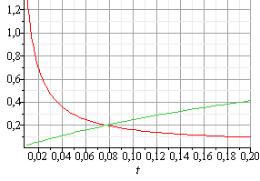
Fig. 1. To the question of determining the critical speed.
Based on (2) and Fig. 1, the following algorithm adaptive to changes in angular velocity is proposed:
If the measured current value of the angular speed is less than the value of the critical speed ($n{≤n}_{c}$), then two microcontroller timers implement the algorithm of instantaneous values tachometer in "adjacent" intervals.
Under the condition $n{>n}_{c}$, the third timer of the microcontroller is programmed to the tachometer algorithm of average values.
Analysis (7) shows that $f_{0}$ and ƶ for a specific schematic implementation are constant values. It is possible to vary only $t_{0}→var$, which allows you to set the required value of the critical speed $n_{c}$.
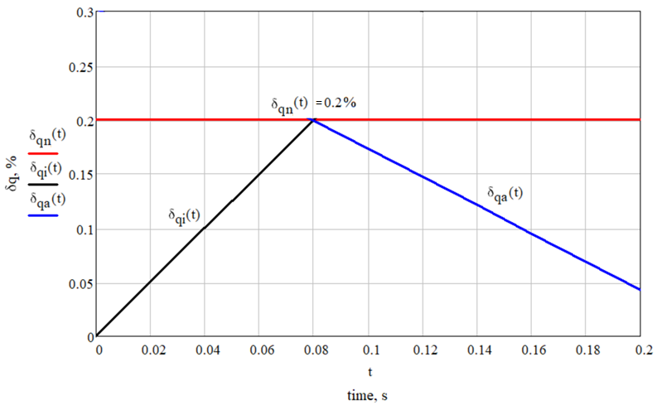
Fig. 2. Characteristics of the change in the normalized values of quantization errors
Conclusion. The analysis of the main metrological characteristics of instantaneous and average values digital tachometers made it possible to propose criterion, the hardware and software implementation of which provided the synthesis of an adaptive (for the changes in angular velocity inherent the EM transients) algorithm of quantization error normalization.
Formulated requirements for hardware and software implementation of a microcontroller tachometer, adaptive to the change in angular velocity during the EM transient, which are shown in its structural diagram.
The essential differences of the synthesized adaptive algorithm are as follows: the first stage – the measurement of the angular velocity is carried out in real time during the transient EM process; the second stage is the processing of the obtained results after the end of the measurement process (transient process).
The usage of the advantages of instantaneous and average values tachometers in one tool ensures the implementation of dynamic measurements with a predetermined normalized value of the quantization error (see Fig. 2). Such adaptive microcontroller tachometers are advisable to use in cases where at the beginning of the transient characteristic of EM, the angular velocity changes significantly over time.

References
- Li, H., Cheng, G.: A Comparative Study of Speed Estimation Methods for Motor Rotor. In Proceedings of 2021 Chinese Intelligent Systems Conference, Volume I, pp. 864-873. Springer Singapore, (2022).
- Rubén Molina Llorente.: Practical Control of Electric Machines, Springer Nature Switzerland AG, Springer Cham, 622 p., (2020).
- Vázquez-Gutiérrez, Y., O'Sullivan, D. L., Kavanagh, R. C.: Small-signal modeling of the incremental optical encoder for motor control. IEEE Transactions on Industrial Electronics, 67(5), pp. 3452-3461, (2019).
- Sziki, G.Á.; Szántó, A.; Kiss, J.; Juhász, G.; Ádámkó, É. Measurement System for the Experimental Study and Testing of Electric Motors at the Faculty of Engineering, University of Debrecen. Appl. Sci. 2022, 12, 10095. https://doi.org/10.3390/app12191009.
- Boggarpu, N. K., Kavanagh, R. C.: New learning algorithm for high-quality velocity measurement and control when using low-cost optical encoders. IEEE Transactions on instrumentation and measurement, 59(3), pp. 565-574, (2009).
- Kukharchuk, V., Vasilevskyi, O., Holodiuk, V.: Results of study of quantization and discretization error of digital tachometers with encoder. Acta IMEKO, 12(2), pp. 1-6, (2023).
- Kukharchuk, V.V., Pavlov, S.V., Holodiuk, V.S.: Information Conversion in Measuring Channels with Optoelectronic Sensors. Sensors 22, 271, (2022). https://doi.org/ 10.3390/s22010271
- A. Veyrat Durbex, Y. Nachajon Schwartz, H. Tacca: Solutions for Torque and Speed Measurement on Electric Machine Controllers Test Benches, Revista elektron, Vol. 5, No. 1, pp. 20-31 (2021).
- S. Y. Yurish and N. V. Kirianaki, "Design of high-performance digital tachometers and tachometric systems based on the method of the depended count," The Experience of Designing and Application of CAD Systems in Microelectronics, 2003. CADSM 2003. Proceedings of the 7th International Conference., Slavske, Ukraine, 2003, pp. 378-381, doi: 10.1109/CADSM.2003.1255096.
- Vasilevskyi, O., Koval, M., Kravets, S.: Indicators of reproducibility and suitability for assessing the quality of production services. Acta IMEKO. Vol. 10, № 4, pp. 54-61, (2021).
- Trishch, R., Cherniak, O., Kupriyanov, O., Luniachek, V., Tsykhanovska, I., M.: Methoology for multi-criteria assessment of working conditions as an object of qualimetry. Engineering Management in Production and Services, 2021, 13(2), Р. 107–114.
- Ginevičius, R., Trishch, R., Bilan, Y., Lis, M., Pencik, J., Assessment of the Economic Efficiency of Energy Development in the Industrial Sector of the European Union Area Countries, Energies, 2022, 15(9) P. 415–423.
- Trishch R., Sichinava A., Bartoš V., Stasiukynas A., Schieg M. Comparative assessment of economic development in the countries of the european union. Journal of Business Economics and Management. 2023. № 24(1). P. 20–36.
- Trishch R., Nechuiviter O., Hrinchenko H., Bubela T., Riabchykov M., Pandova I. Assessment of safety risks using qualimetric methods. MM Science Journal, October 2023. P. 6668 -6674.
- Trishch, R, Maletska, О, Hrinchenko, Н et. al. 2019, ‘Development and validation of measurement techniques according to ISO/IEC 17025:2017. Proceedings of the 8th International Conference on Advanced.

